|  |
| --- |
| Database System |
| Database Design Strategies |
| Presentation Slides Explanation |

|  |
| --- |
| Taimoor Ul Islam  4-17-2024 |

# Introduction

## DEFINITION OF DATABASE DESIGN:

Database design encompasses the process of structuring and organizing data within a database system to meet specific requirements and objectives. It involves defining the database schema, tables, relationships, constraints, and other elements necessary for efficient data storage, retrieval, and manipulation. Essentially, database design determines how data is stored, accessed, and managed within a system.

## INTRODUCTION TO THE IMPORTANCE OF DATABASE DESIGN.

Why Database Design Matters: Database design lays the foundation for efficient data management, retrieval, and scalability within applications.

Impact on Performance: Poor database design can lead to slow query execution, data redundancy, and overall system inefficiency.

Scalability and Adaptability: Well-designed databases can scale seamlessly as data volume and user load increase, ensuring the longevity and flexibility of the application.

Foundation for Decision Making: Database design influences the ease of data analysis, reporting, and decision-making processes within organizations.

# Database Design Principles

Database design relies on several key principles to ensure the efficient organization, management, and optimization of data within a system. Understanding and applying these principles are essential for creating robust, scalable, and high-performing databases. Let's explore the core principles of database design:

* Normalization
* Denormalization
* Data Integrity
* Scalability
* Performance Optimization

# Normalization

Normalization is a systematic approach to organizing data in a database to minimize redundancy and dependency, thereby improving data integrity and efficiency. It involves breaking down large tables into smaller, related tables and defining relationships between them. Normalization is typically divided into several normal forms, including:

## 1NF (First Normal Form):

In 1NF, each table cell should contain a single value, and each column should represent a unique attribute.

It eliminates repeating groups within rows and ensures atomicity of data.

## 2NF (Second Normal Form):

2NF builds upon 1NF by removing partial dependencies.

It requires that every non-key attribute be fully functionally dependent on the primary key.

## 3NF (Third Normal Form):

3NF further eliminates transitive dependencies.

It ensures that non-key attributes are dependent only on the primary key and not on other non-key attributes.

## BCNF (Boyce-Codd Normal Form):

BCNF is a stronger version of 3NF that addresses certain anomalies that may arise in 3NF.

It requires that every determinant be a candidate key.

Benefits of Normalization:

## Normalization offers several benefits, including:

Reducing Redundancy: By organizing data into separate tables and eliminating redundant information, normalization minimizes storage space and ensures data consistency.

Improving Data Integrity: Normalization reduces the risk of anomalies, such as insertion, update, and deletion anomalies, which can compromise data integrity.

# Denormalization

Denormalization is the process of intentionally introducing redundancy into a database schema to improve query performance or simplify data retrieval. Unlike normalization, which aims to eliminate redundancy and dependency, denormalization strategically reintroduces redundancy to optimize specific aspects of database operations.

## When to Denormalize:

### Improving Query Performance:

Denormalization is often employed to enhance the performance of read-heavy queries, particularly in systems where frequent joins across normalized tables lead to increased processing overhead.

By duplicating data and flattening table structures, denormalization reduces the need for complex joins, resulting in faster query execution times.

### Reducing Joins:

Joins are fundamental operations in relational databases for retrieving related data from multiple tables.

However, excessive joins can impact query performance, especially in scenarios involving large datasets or complex join conditions.

Denormalization can mitigate this issue by consolidating related data into a single table, minimizing the need for joins and simplifying data retrieval

.

# Data Integrity

Data integrity is paramount in database design as it ensures the accuracy, consistency, and reliability of data stored within a database. Maintaining data integrity is crucial for preserving the quality and trustworthiness of information, thereby enabling informed decision-making and reliable application functionality.

## Techniques for Enforcing Data Integrity:

### Constraints (e.g., Unique, Not Null):

Constraints are rules or conditions applied to database columns to enforce data integrity at the column level.

Common constraints include:

Unique Constraint: Ensures that each value in a column is unique across the table.

Not Null Constraint: Prevents null values from being inserted into a column, ensuring that it always contains valid data.

By enforcing these constraints, databases can prevent the insertion of duplicate or invalid data, thereby maintaining data integrity.

### Triggers:

Triggers are database objects that automatically execute in response to specified events, such as insertions, updates, or deletions of data.

Triggers can be used to enforce complex data integrity rules or perform additional validation logic beyond what constraints can accomplish.

For example, a trigger can be implemented to enforce referential integrity or perform custom data validation before allowing data modification operations.

### Referential Integrity:

Referential integrity ensures that relationships between tables remain consistent and valid.

Foreign key constraints are used to enforce referential integrity by specifying that values in a column (foreign key) must correspond to values in another column (primary key) in a related table.

By enforcing referential integrity, databases prevent orphaned or inconsistent data, maintaining the integrity of relational data relationships.

# Scalability

Scalability is the capability of a database system to handle increased workload or data volume without sacrificing performance or availability. It's a critical aspect of database design, ensuring that systems can adapt and grow to meet changing demands efficiently.

## Horizontal vs. Vertical Scalability:

### Horizontal Scalability:

Definition: Horizontal scalability, also known as scale-out, involves adding more machines or nodes to a database system to distribute the workload across multiple instances.

Advantages: Offers incremental growth, improved fault tolerance, and easier maintenance.

Example: Adding more database servers to a cluster to accommodate increased user traffic.

### Vertical Scalability:

Definition: Vertical scalability, or scale-up, involves increasing the resources (e.g., CPU, memory) of existing servers to handle increased workload.

Advantages: Immediate performance improvements and simplified management.

Example: Upgrading a server's CPU and RAM to support higher transaction rates.

## Techniques for Achieving Scalability:

### Sharding:

Definition: Sharding involves horizontally partitioning data across multiple database instances or shards based on a shard key.

Example: Partitioning customer data based on geographical regions across different database servers.

### Replication:

Definition: Replication involves maintaining copies of data across multiple database instances or nodes.

Example: Replicating a database to secondary nodes for read scalability and disaster recovery.

### Partitioning:

Definition: Partitioning involves dividing large tables into smaller, more manageable partitions based on specific criteria (e.g., range, hash).

Example: Partitioning historical sales data by year to improve query performance.

# Performance Optimization

Strategies for Optimizing Database Performance:

## Indexing:

Definition: Indexes are data structures that improve the speed of data retrieval operations by enabling faster lookup of records based on specific columns.

Benefits: Indexes reduce the need for full-table scans and improve query performance, especially for frequently accessed columns.

Example: Creating indexes on columns used in WHERE clauses or JOIN conditions to accelerate query execution.

## Query Optimization:

Definition: Query optimization involves analyzing and modifying SQL queries to improve their efficiency and execution speed.

Techniques: Strategies include using proper JOIN types, minimizing the use of wildcard characters in LIKE clauses, and avoiding unnecessary subqueries.

Example: Rewriting a complex query to utilize efficient JOIN conditions and filter criteria.

## Caching:

Definition: Caching involves storing frequently accessed data in memory to reduce the need for repeated database queries.

Benefits: Caching improves response times and reduces database load, particularly for read-heavy applications.

Example: Implementing a caching layer using tools like Redis or Memcached to store query results or frequently accessed data objects.

## Compression:

Definition: Compression reduces the size of stored data to minimize storage requirements and improve I/O performance.

Benefits: Compression reduces disk space usage and speeds up data transfer between storage and memory.

Example: Using database features or external tools to compress data before storage, especially for large text or binary fields.

## Benchmarking and Profiling Techniques:

Definition: Benchmarking involves measuring the performance of database operations under specific conditions to identify bottlenecks and areas for improvement.

Techniques: Profiling tools help analyze query execution plans, identify slow-performing queries, and optimize resource usage.

Example: Using tools like EXPLAIN in SQL to analyze query execution plans and identify potential performance optimizations.

# Database Design Strategies

## Top Down Vs Bottom Up

### Top Down Approach

The top-down design method starts from the general and moves to the specific. In other words, you start with a general idea of what is needed for the system and then work your way down to the more specific details of how the system will interact. This process involves the identification of different entity types and the definition of each entity’s attributes.

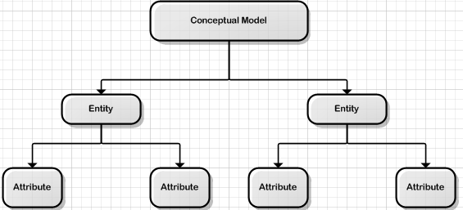

### Bottom Up Approach

The bottom-up approach begins with the specific details and moves up to the general. This is done by first identifying the data elements (items) and then grouping them together in data sets. In other words, this method first identifies the attributes, and then groups them to form entities.

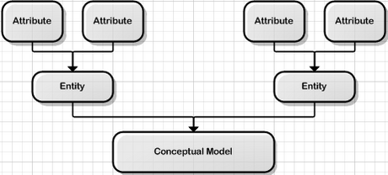

### Selection Criteria

Two general approaches (top – down and bottom – up) to the design of the databases can be heavily influenced by factors like scope, size of the system, the organizations management style, and the organizations structure. Depending on such factors, the design of the database might use two very different approaches, centralized design and decentralized design.

## Centralized Vs Distributed

### Centralized Approach

Centralized design is most productive when the data component is composed of a moderately small number of objects and procedures. The design can be carried out and represented in a somewhat simple database. Centralized design is typical of a simple or small database and can be successfully done by a single database administrator or by a small design team. This person or team will define the problems, create the conceptual design, verify the conceptual design with the user views, and define system processes and data constraints to ensure that the design complies with the organizations goals. That being said, the centralized design is not limited to small companies. Even large companies can operate within the simple database environment.

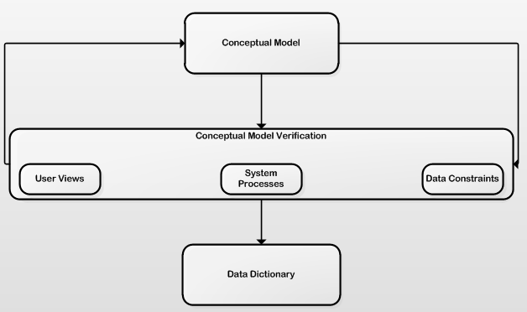

### Decentralized Approach

Decentralized design might best be used when the data component of the system has a large number of entities and complex relations upon which complex operations are performed. This is also likely to be used when the problem itself is spread across many operational sites and the elements are a subset of the entire data set. In large and complex projects a team of carefully selected designers are employed to get the job done. This is commonly accomplished by several teams that work on different subsets or modules of the system. Conceptual models are created by these teams and compared to the user views, processes, and constraints for each module. Once all the teams have completed their modules they are all put aggregated into one large conceptual model.

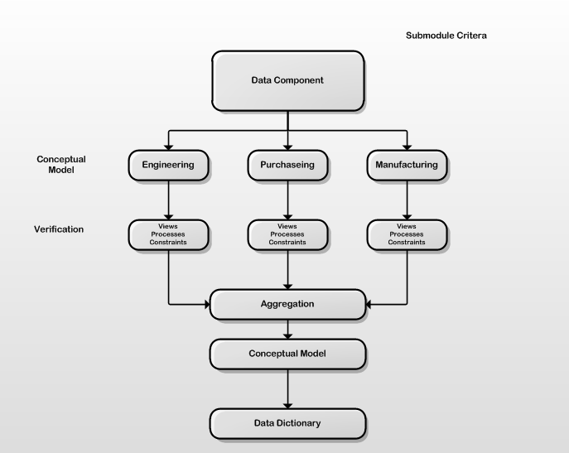

# Database Design Tools and Technologies

## Overview of Popular Database Design Tools:

### ER Modeling Tools:

Definition: Entity-Relationship (ER) modeling tools assist in designing and visualizing database schemas using entity-relationship diagrams.

Features: ER modeling tools allow users to define entities, attributes, and relationships between entities, facilitating the creation of well-structured database designs.

Examples: Software tools like Lucidchart, ER/Studio, and Microsoft Visio are commonly used for ER modeling.

### Database Management Systems (DBMS):

Definition: DBMS platforms provide a comprehensive suite of tools and services for managing databases, including schema design, data manipulation, and administration.

Examples: Popular DBMS platforms include MySQL, PostgreSQL, Oracle Database, Microsoft SQL Server, and MongoDB.

Integrated Development Environments (IDEs): Many DBMS platforms come with integrated development environments (IDEs) such as MySQL Workbench, Microsoft SQL Server Management Studio (SSMS), and pgAdmin for database design and administration tasks.

## Emerging Technologies Impacting Database Design:

### NoSQL Databases:

Definition: NoSQL (Not Only SQL) databases are non-relational database management systems designed to handle large volumes of unstructured or semi-structured data.

Advantages: NoSQL databases offer flexible schema designs, horizontal scalability, and high performance for specific use cases like real-time analytics, IoT, and web applications.

Examples: MongoDB, Cassandra, Couchbase, and Redis are popular NoSQL databases used for various applications.

### NewSQL Databases:

Definition: NewSQL databases are a class of relational databases that aim to combine the scalability of NoSQL databases with the ACID (Atomicity, Consistency, Isolation, Durability) guarantees of traditional SQL databases.

Advantages: NewSQL databases provide horizontal scalability, distributed transactions, and support for SQL queries, making them suitable for modern, high-performance applications.

Examples: CockroachDB, Google Spanner, and NuoDB are examples of NewSQL databases gaining traction in the industry.

# Case Studies

## Examples of Successful Database Designs

### 1. Facebook's Social Graph Database

Design: Facebook's social graph database is a massive graph database that represents connections between users, pages, and interests.

Key Features: Highly optimized for read-heavy workloads, with efficient graph traversal algorithms and caching mechanisms.

Scalability: Horizontal scalability achieved through sharding and partitioning of data across multiple servers.

Lessons Learned: Effective use of denormalization and caching to improve query performance and scalability.

### 2. Amazon's DynamoDB

Design: DynamoDB is a highly available and scalable NoSQL database service provided by Amazon Web Services (AWS).

Key Features: Distributed architecture with automatic partitioning and replication for high availability and fault tolerance.

Scalability: Scales horizontally to handle millions of requests per second across multiple data centers.

Lessons Learned: Trade-offs between consistency, availability, and partition tolerance in distributed systems. DynamoDB prioritizes high availability and scalability over strong consistency.

## Lessons Learned from Database Design Failures

### 1. MySpace Data Loss Incident

Incident: MySpace experienced a significant data loss incident in 2019, leading to the deletion of over 12 years' worth of user-uploaded music, photos, and videos.

Cause: Inadequate backup and recovery procedures, combined with hardware failure, resulted in the permanent loss of user data.

Lesson: Importance of robust backup and disaster recovery mechanisms to prevent data loss and ensure business continuity.

### 2. LinkedIn's Database Outage

Incident: LinkedIn experienced a database outage in 2020, resulting in service disruption and data inconsistency for users.

Cause: Database schema changes performed without proper testing and validation led to data corruption and downtime.

Lesson: Importance of thorough testing and validation procedures for database changes to avoid unintended consequences and service disruptions.

# Conclusion

## Summary of Key Points Covered:

Throughout this presentation, we've explored the critical aspects of database design, including normalization, denormalization, data integrity, scalability, and performance optimization.

We've learned how normalization organizes data to minimize redundancy and dependency, while denormalization strategically introduces redundancy to improve query performance.

Techniques such as indexing, query optimization, caching, and compression are essential for optimizing database performance and ensuring efficient data retrieval.

Scalability considerations, including horizontal and vertical scalability, sharding, and replication, are fundamental for designing databases that can grow and adapt to meet evolving demands.

## Importance of Continuous Optimization and Adaptation:

Database design is an ongoing process that requires continuous optimization and adaptation to meet changing business needs and technological advancements.

As data volumes and user loads increase, database systems must evolve to maintain performance, scalability, and data integrity.

Regular performance monitoring, benchmarking, and profiling are essential for identifying bottlenecks and implementing optimizations to enhance database efficiency.

## Encouragement for Further Exploration and Learning:

The field of database design is vast and continuously evolving, offering endless opportunities for exploration and learning.

By staying informed about emerging technologies, best practices, and industry trends, database professionals can remain at the forefront of innovation and contribute to the development of robust and scalable database solutions.